**Homework 10 – Network theorem: Thevenin’s theorem and maximum power transfer**

**Due date: Monday 11/28/16**

1. For the following circuit below:
   1. Determine the Thevinin’s equivalent circuit (15 points)
   2. Using the Thevenin’s equivalent circuit, determine the voltage through the load resistor ***R*** = 3 Ω (5 points)
   3. Using the Thevenin’s equivalent circuit, determine the load resistor if the load voltage drop through it is 8 V (5 points)
   4. Find the maximum power transfer to R (5 points)

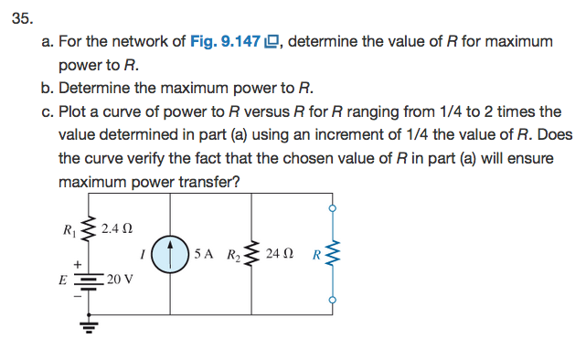

1. For the following circuit,
2. Find the Thevenin’s equivalent circuit for the resistor R (15 points)
3. According to the Thevenin’s equivalent circuit, what will be the voltage through R if R = 5Ω? (5 points)
4. According to the Thevenin’s equivalent circuit, what will be the maximum power transfer through R? (5 points)

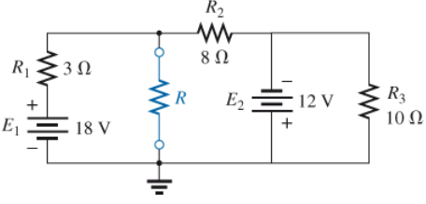

1. For the following circuit below:
   1. Determine the Thevinin’s equivalent circuit (15 points)
   2. Using the Thevenin’s equivalent circuit, determine the voltage through the load resistor ***R*** = 2 Ω (5 points)
   3. Using the Thevenin’s equivalent circuit, determine the load resistor if the load voltage drop through it is 5 V (5 points)
   4. Find the maximum power transfer to R (5 points)

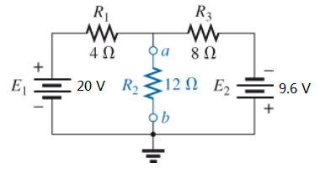

1. For the following circuit below:

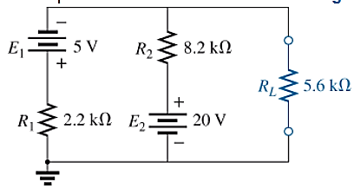

1. Determine the Thevinin’s equivalent circuit (15 points)
2. Using the Thevenin’s equivalent circuit, determine the load resistor if the load voltage drop through it is 100 mV (5 points)
3. Find the maximum power transfer to R (5 points)